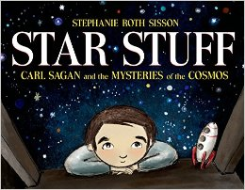
Session Title: Mapping the Great Galaxy Wall
Session Date/Time: Monday, July 18/1:30-4pm

Essential questions/big idea:
How does wonder lead to discovery? Where are we in the universe?
Mapping one’s place in the universe – connectivity between my environment and people around me

Core text - Star Stuff: Carl Sagan and the Mysteries of the Cosmos by Stephanie Roth Sisson

Standard(s):
VA:Cr2.3.5a - Identify, describe, and visually document places and/or objects of personal significance

LAFS.5.RI.1.1: Quote accurately from a text when explaining what the text says explicitly and when drawing inferences from the text.

Performance Task(s): Storyboard, 2D Map

“Square astronaut, round hole. But somehow, I’d managed to push myself through it, and here was the truly amazing part: along the way, I’d become a good fit. It had only taken 21 years.”
― Chris Hadfield, An Astronaut's Guide to Life on Earth

Procedure:
Discussion & Slide Show: Exploration of markers & maps
Mapping the Great Galaxy Wall
- Watercolor technique
- Layering
Reflection
